Zachary Scott

Caleb Tenney

Mason Juarez

CSCI 156 Networking Project

Auctioneer

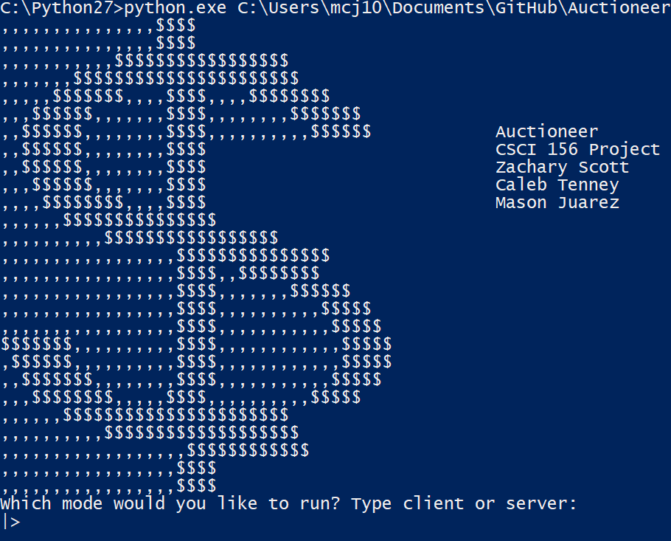

Our project is an server/client auctioning system that features a fully autonomous auctioneer server and fully autonomous bidding clients. The auctioneer server begins by using a test item with 10 quantity, along with their prices and unit availability, from which it selects to auction off. The server then waits for incoming connections from client instances, who may at this point join before bidding starts. Once the auction begins, the server sends the item to all the clients who joined.

The clients all decide if they want to join in bidding on the current item, with a 30% chance not to bid. When the client receives the item price, it establishes a maximum price it will bid up to, based on a percent of the original price. The client also selects a random int between 1 and 10 to increment its bidding amount. If the client is outbid, they will continue to bid until they reach their max price. Once the bidding is over for the item, it moves onto the next. This continues until the quanity of the item has depleted